**4. Data Exploration**

**Pie Chart - Genres**

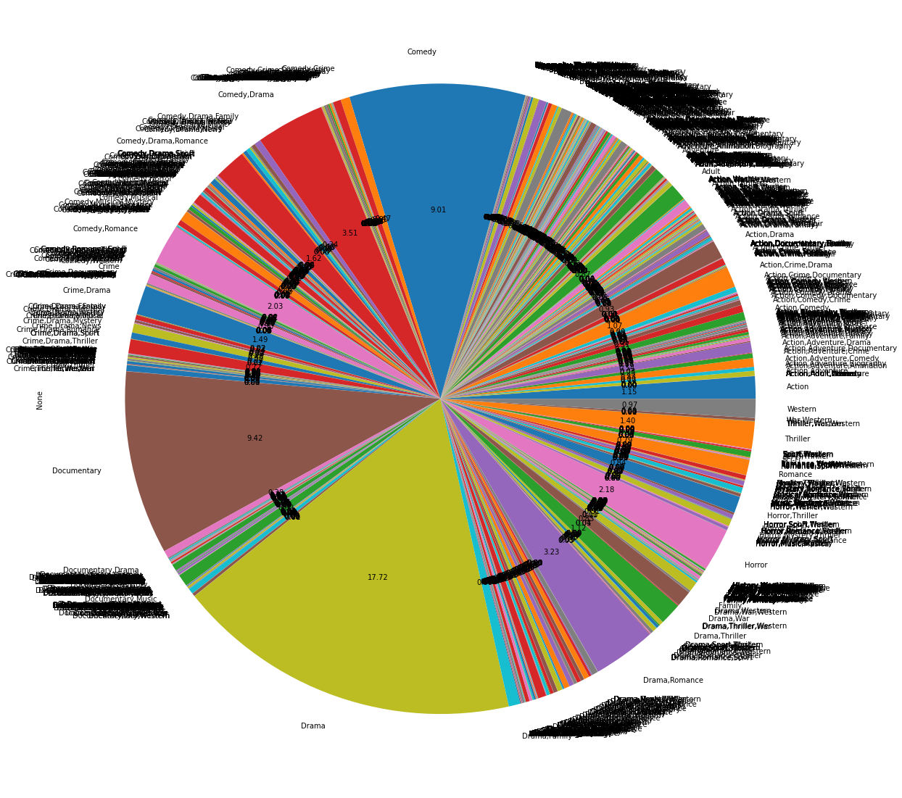

### Wordcloud viz – Genres

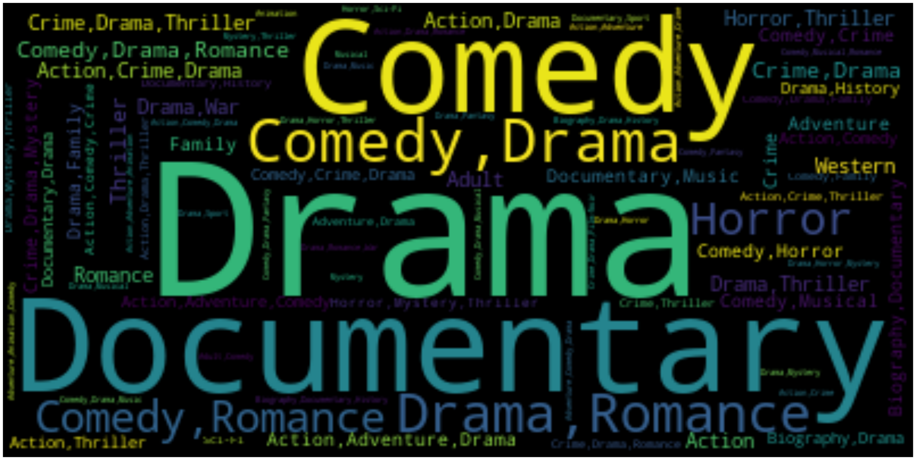

### Pie Chart - Percentage of non-adult movies

### 

### Box Plot – averageRating

### 

### Distribution - averageRating

### 

### Distribution - Avg rating belongs to the crews of a given movie title (excluding the rating of the given title itself while computing the crew average rating to avoid data leakage )

### 

### Distribution - Avg number of titles associated with the crews for a given movie title (excluding the title itself while computing to avoid data leakage)

### 